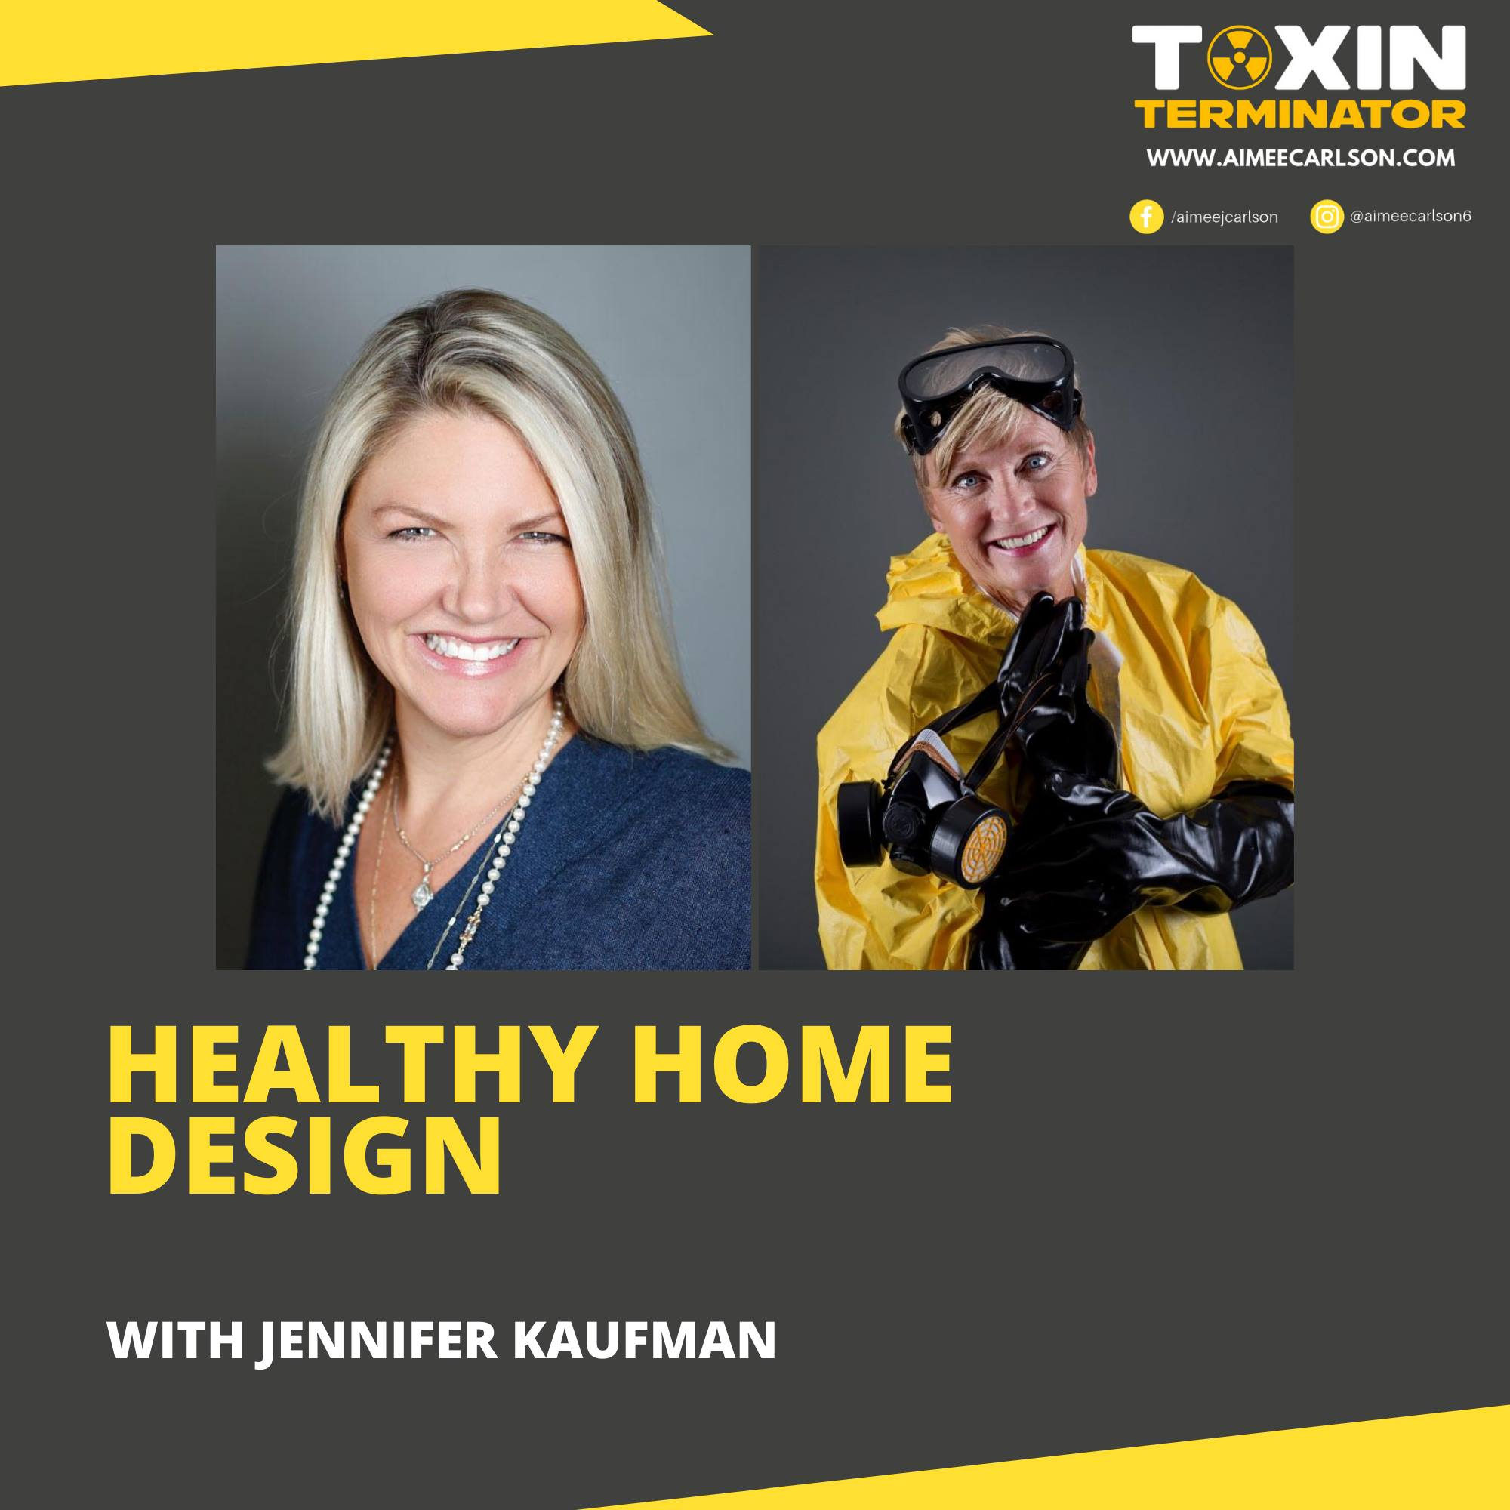
HEALTHY HOME DESIGN
Click here to join me as I walk room by room and show you what to get rid of NOW!

The Toxin-Free Lifestyle
Join me as I walk room by room, showing what to get rid of now!

Facebook Community
Join our group where people like you are learning to live a toxin-free lifestyle. We post daily content with suggestions and tips to help us all on our journey as well as featured speakers to do live Q&A’s!
THE TOXIN-FREE LIFESTYLE

FREE Toxic-Risk Assessment
I don’t know if you’re like me, but I had no idea so many of the products I was using in my home were actually making me sick! Take my free assessment now and see where potential exposures are for you and your family.
TAKE THE ASSESSMENT HERE

Toxin-Free Home Shopping Guide
Just want the easy button? Me too! Grab this guide for my favorite products that help me keep my home toxin-free!
FREE GUIDE
This week I was joined by joined by Jennifer Kaufman! She is an artist and Art of Transformation creator and advisor. She researched for over a year to create a completely toxin free home and stresses the importance of learning to get and read MSDS forms. (Material Safety Data Sheets)

In this episode you'll learn:
• How she used energy and acupuncture points of nature to create a truly healthy environment in their home!
• How she designed the home to make the most of sound and light within their living spaces!
• How she found sustainable building materials were used and made sure there was zero waste!
• What websites and resources she used!

Listen here: https://shows.acast.com/the-toxin-terminator/episodes/healthy-home-design-with-jennifer-kaufman
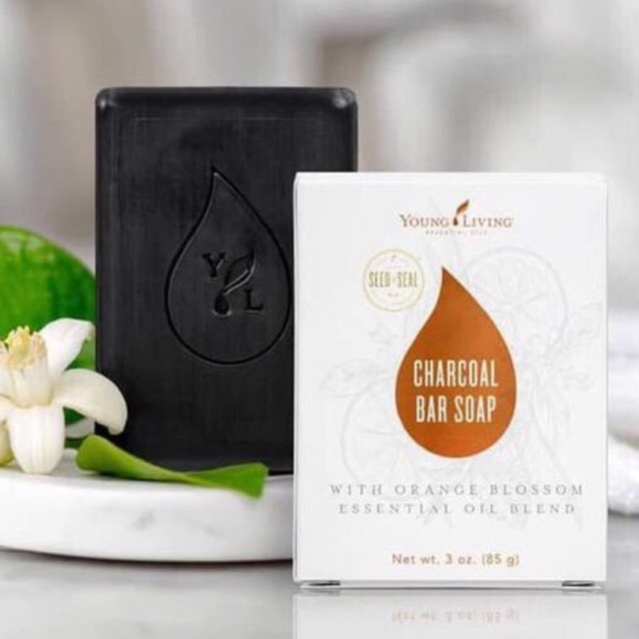
On Thursday I was joined by Dr. Que Collins!

He is a leading scientist when it comes to developing and applying nutrition and metabolic therapies to treat cancer in people and pets.

Multi-Use Products
One of the things I love is being able to purchase products that have multiple uses. Like this charcoal bar soap, designed to be used for our face, but check out these other uses I found:
- Overall Body Wash
- Armpit Detox
- Once a week hair purifier
- Great stain stick for the laundry room!

Shop Water Filters Here

In this episode you'll learn:
- What is metabolic health
- What mitochondria really do
- What Deuterium is and how it affects our body
- What the root causes of too much deuterium are

Listen here: https://shows.acast.com/the-toxin-terminator/episodes/whats-the-real-root-cause-with-dr-que-collins

