[](http://www.youngliving.com/)

**Carrier Oils**

**What are carrier oils?**

Carrier oils are naturally derived from vegetarian sources and have a neutral smell. They aren’t volatile like essential oils, which makes them an excellent medium for dilution and application.

**What aren’t carrier oils?**

Vegetable shortening, butter, and margarine are best left in the kitchen—they’re not intended for topical use. Mineral oil and other petroleum derivatives like petroleum jelly should also not be used as carrier oils.

**How are carrier oils used?**

Essential oils are volatile, which means they evaporate rapidly and contain the natural smell and characteristics of the plant. This can make them too strong to apply undiluted. Carrier oils do not evaporate or have a strong aroma, making them the perfect pair for diluting especially strong essential oils—reducing the concentration of the essential oil without altering its therapeutic qualities. When you dilute an essential oil with a carrier oil, you can also control its concentration before applying.

Like other substances that are high in fat, carrier oils have a limited shelf life, meaning that eventually they can go bad. Depending on the type, oils with a short shelf life should typically be used within six months, while oils with a longer shelf life may stay good for up to a year. It’s important to store oils in their original air-tight containers in a cool, dark place, such as the pantry, to maximize shelf life.

**[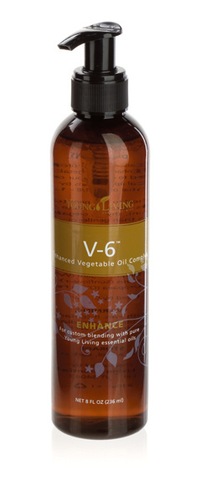](https://www.youngliving.com/en_US/products/essential-oils/massage-oils/v-6-enhanced-vegetable-oil-complex)**Carrier oils can vary widely in their consistency, absorption, aroma, shelf life, and other characteristics. Carrier oils can be blended to change or combine their properties, so you can mix and match until you find the blend that’s just right for you!

**Young Living** [**V-6**](https://www.youngliving.com/en_US/products/v-6-enhanced-vegetable-oil-complex)**\*\***

* A proprietary Young Living formula combining fractionated coconut oil, grapeseed oil, sweet almond oil, wheat germ oil (contains a lot of vitamin E and acts as a natural preservative), sunflower oil, and olive oil
* Moisturizes and nourishes the skin
* An excellent carrier oil for all your [best essential oils](https://www.youngliving.com/en_US/products/essential-oils) and applications

**Caution: May cause a reaction to those with nut allergies.

**Other Carrier Oils**

**Grapeseed Oil**

**Sweet Almond Oil\***

**Jojoba Oil**

**Olive Oil**

**Fractionated Coconut Oil**

**Coconut Oil**

**Cocoa Butter**

**Shea Butter**