Lymphedema refers to swelling that generally occurs in one of your arms or legs. Although lymphedema tends to affect just one arm or leg, sometimes both arms or both legs may be swollen.
Lymphedema is caused by a blockage in your lymphatic system, an important part of your immune and circulatory systems. The blockage prevents lymph fluid from draining well, and as the fluid builds up, the swelling continues.
There's no cure for lymphedema, but it can be controlled. Controlling lymphedema involves diligent care of your affected limb.
Symptoms
Click to enlarge
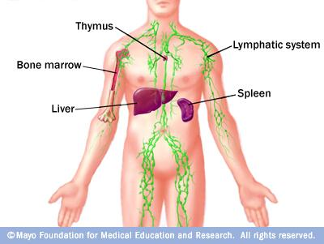
Your body's lymphatic system is part of your immune system, which protects you against infection and disease. It includes your spleen, thymus, bone marrow, lymph nodes and lymph channels, as well as your tonsils and adenoids.
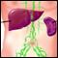Lymphatic system
Click to enlarge
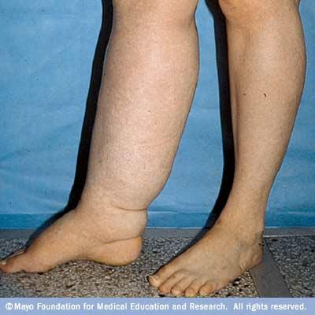
Lymphedema is swelling in an arm or leg. In rare circumstances it affects both arms or both legs.
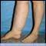Leg lymphedema
Lymphedema symptoms include:
- Swelling of part of your arm or leg or your entire arm or leg, including your fingers or toes
- A feeling of heaviness or tightness in your arm or leg
- Restricted range of motion in your arm or leg
- Aching or discomfort in your arm or leg
- Recurring infections in your affected limb
- Hardening and thickening of the skin on your arm or leg
The swelling caused by lymphedema ranges from mild, hardly noticeable changes in the size of your arm or leg to extreme swelling that can make it impossible to use the affected limb.

