# **Hibernation and Restoration During the Winter**

## ***A FIVE-PART SERIES FOR THE WINTER SEASON***

An Official Welcome to Winter! For those that live in the Midwest, we recently received an intense ice storm and boy….it was a doozy! But in all truth, there is really nothing new under the sun, this is not the first snow and ice storm we have here and I’m sure it won’t be the last.

***However, you, O Lord, are always present to protect me, and you grant life to my spirit; you will restore me to health and enable me to live. Isaiah 38:16***

## **Part 1**

In today’s blog, I want to spend time talking about the winter season, what it brings to your body, soul and spirit and how to take advantage of this season of *hibernation and restoration*. Overall, restoration in each of these areas (body, soul and spirit) is the perfect opportunity to come closer spiritually and go deep into what the Lord is speaking to you, the same goes in the physical, mental and emotional aspect.

**So what is hibernation?**

It is a state of deep rest and inactivity, some synonyms are retreat, sleep, lie low, seclude oneself, go quiet.

* Focusing on the physical body it means: to heal, recover your energy and sleep.
* In the mental and emotional state, it means stress relief, emotional reset, creativity and focus
* In the Spiritual, it means faith renewal and healing the soul

**And what is restoration?**

It is the process of renewing, repairing or replenishing.

Both hibernation and restoration are interconnected, *to hibernate* is also *to restore*, it’s not just the animals that hibernate to conserve energy, repair their bodies, and survive challenging conditions during the winter but also as humans, we also are conserving energy, repairing our bodies through the winter season.

As you look at your physical and mental and spiritual state; do you find it hard sometimes to work out? Do you just want to stay in bed more hours or all day? Do you prefer to drink something warm or hot? Crave broths or soups? All this is normal, the body wants to rest during the winter months and use this time to conserve your body, mental and emotional state, especially restore your relationship with the Lord. This time is not a coincidence, and it should not be taken lightly.

# **Restoration During Hibernation**

**PART 2:**

**In the following section**, I provide information, tips and resources to prepare and set up your body, spirit and mind for success during the winter season and be ready to thrive for the Spring season! Before you know it, spring will come quickly, and we want to make sure it’s ready and primed to thrive!

***For I will provide the weary with all they need, and I will restore the strength of all those who have grown faint with hunger. Jeremiah 31:25***

# **Positive and negative effects of winter**

The winter season brings both negative effects to our life and positive effects that we can take advantage during this time. During the “hibernation” season our bodies go through a time of restoration and healing, especially that we just finished the holiday season where perhaps we didn’t make the best choices in eating healthy or drinking. And so here we are in January, where perhaps we feel “off” “sluggish” and “mentally drained” due to the buildup of mucus we accumulated in our body; this of course can negatively impact the mind, emotions, and increase the risk of colds, viruses, illnesses, etc. However, we will not worry because we will discuss great options for cleansing and detoxing the body with foods, fluids, supplements and other resources you can try, but first let’s talk a little more on the negative effects in the winter season.

## **Negative Effects:**

* Less Sunlight: in the winter we see a decrease in sunlight and the change of daylight savings time and therefore lose one hour of sleep and sun. By having less sunlight our serotonin levels decrease which can lead to depression, fatigue and mood swings and it also disrupts our sleep cycles which leads to tiredness and difficult waking up.
* Vitamin D Deficiency: because of less sun exposure our body produces less Vit D, this is important for bone health, immunity and mood regulation, having low Vit D leads to fatigue, depression and a weakened immune system.
* Increased Illnesses: colds, flu and respiratory diseases are prevalent during this time, the sun plays such an important role as it helps to fight of cold and flus, due to the decrease in sunlight this makes it harder for our bodies to fight colds.
* Sedentary Lifestyle: depending on where you live, less movement and exercise occurs during the winter season, either because of snow, too cold, low energy can
* Dry Skin / Hair Issues: lack of Humidity, cold air outside and heated indoor create a lot of static in your environment and strips moisture from the skin which leads to dryness, irritation and chapped lips. The same goes for your hair and scalp.

## **Positive Effects**

There are great positive effects during the winter season, remember that this is the time for the body to restore and hibernate, let’s look at the things you can do that can positively impact your body, mind and spirit.

* Cleansing and Detoxing the Body:
* Support your Body with Detox Products and Supplements
* Hearty and Substantive Food Choices During the Winter
* Rest
* Saunas, Steam and Hot Baths
* Exercise and Movement

# **PART 3: CLEANSING AND DETOXING THE BODY**

***This will provide healing for your flesh and restore strength to your body. Proverbs 3:8***

## **BEVERAGES / DRINKS THAT SUPPORT DETOX**

Below are great options for natural beverages or drinks you can consume during the winter season and can also help detox your body:

* + Drink pure and quality water, this helps our bodies and skin stay moisturized during the winter where there is a lot of static and dryness; you can add mineral drops or pure Celtic salt to your water to add those electrolytes back in your body and reduce cramping
  + Teas or Ponches: Drinking homemade teas with fresh herbs or spices with some honey during the winter or ponche (a hot fruit drink) is perfect during the winter as it is loaded with vitamin C and other vitamins and minerals
  + Drink fresh fruit or vegetable juices: celery, beet, grapefruit, pineapple, etc and add turmeric, ginger if you’d like this gives a boost to your immune system and has a high Vit C content- a great detoxifier too!
  + Chicken broths is a great healthy fat to drink; adding onions, carrots, chicken, and boiling this in water you get the healthy fat and vitamins from the vegetables
  + If possible, reduce dairy since it can create mucus build up in your body

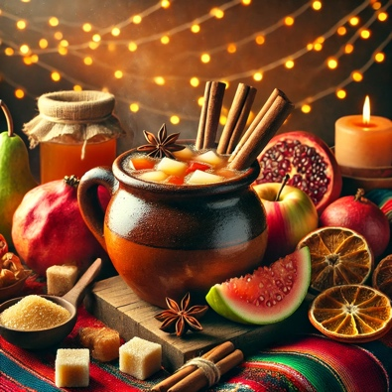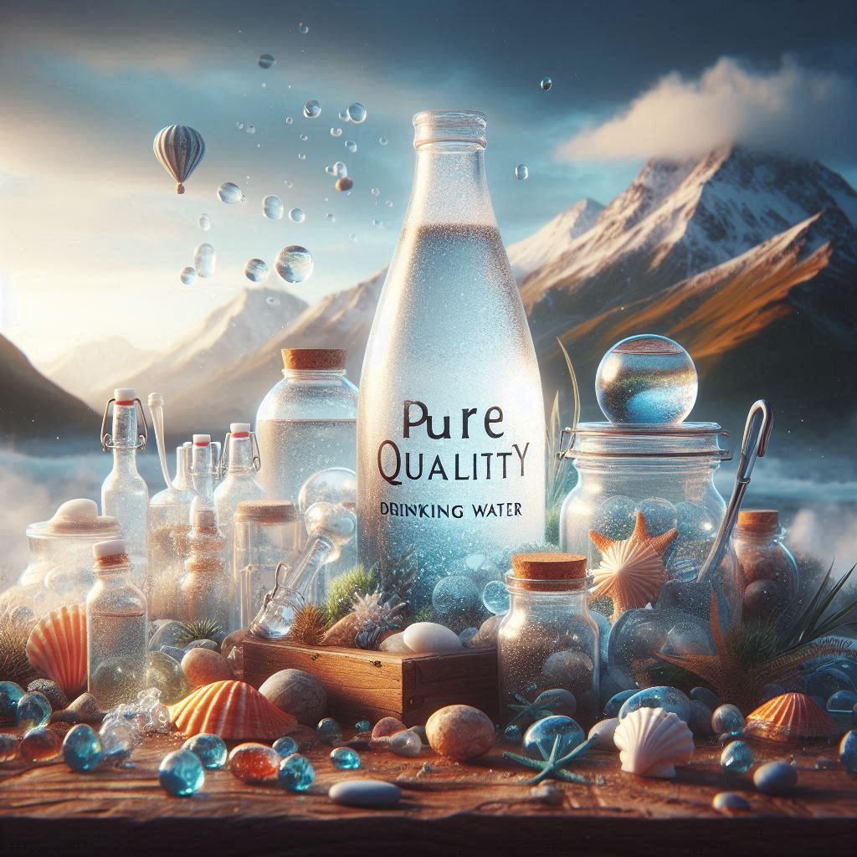

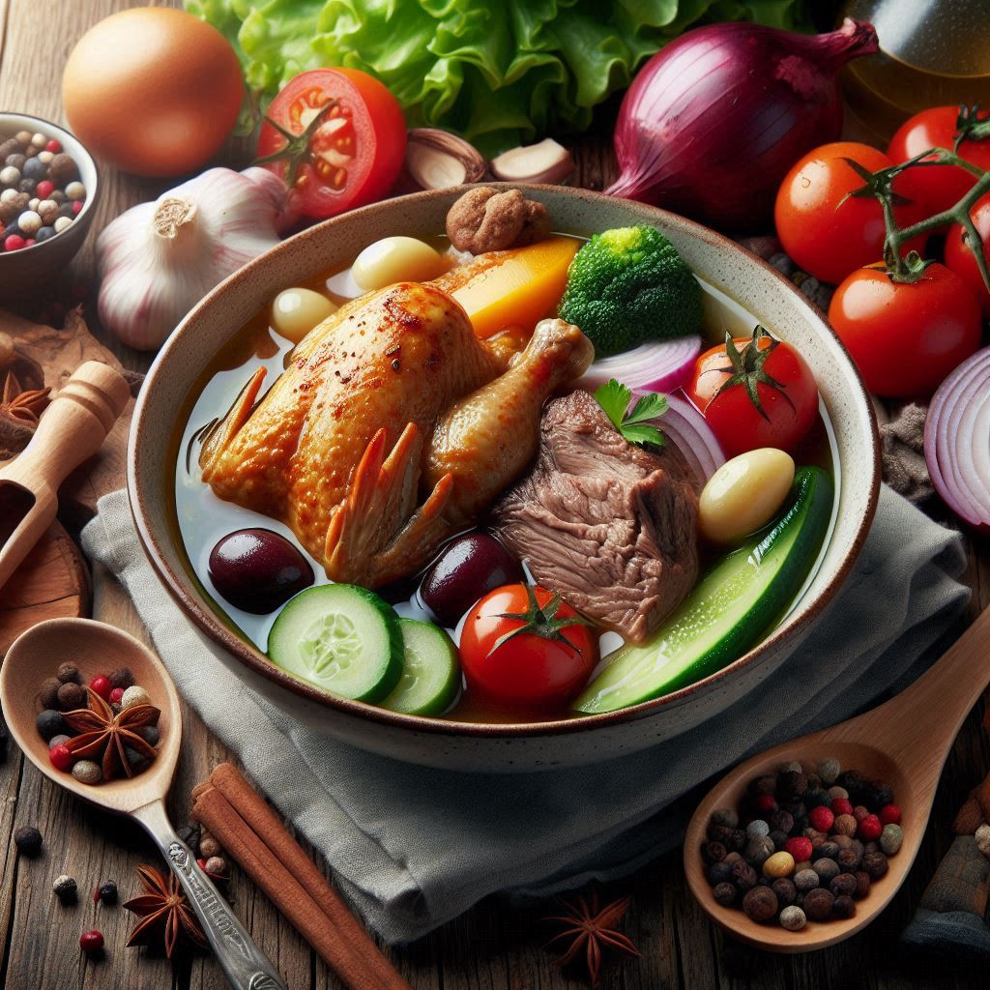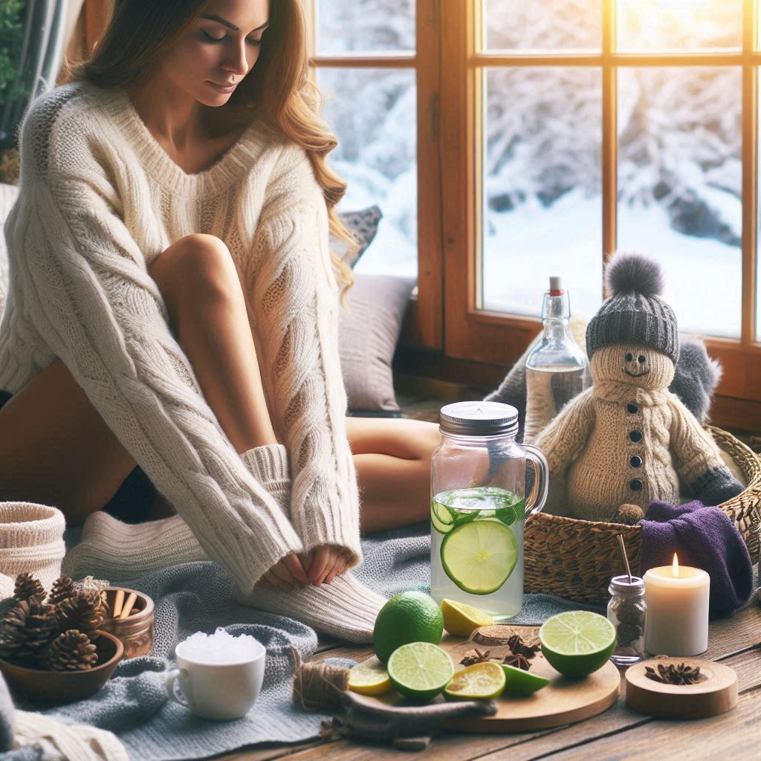

***This time is the perfect time for you to heal your body (health), soul (balance), and spirit (vitality).***

## **DETOX PRODUCTS AND SUPPLEMENTS**

Whether the winter or summer season, detoxing the body should be a focal point to our life. The body is constantly bombarded by seasonal changes, food contaminants, stressful work environment, air quality and pollution and many more so it is important that we choose the best pure quality supplements during the winter or any season but also that we choose the best pure detox products that will heal our bodies and support our immune system. When it comes to cleansing and detoxing, it is important to detox the gut (intestinal) and the liver during this time and every season as it resets our immune system and prepares us for changes and contaminant’s we face year-round.

Some great supplements for the winter and year round are:

* [Vitamin D3](https://go.globalhealingcenter.com/c/5617054/1728854/5534)- great for strong bones, nails, brain and immune system
* [Iodine](https://go.globalhealingcenter.com/c/5617054/1975284/5534)- great for detoxification, healthy thyroid and hormone balance
* [Elderberry and Echinacea](https://go.globalhealingcenter.com/c/5617054/885519/5534)- great as a natural immune support for the winter months
* [Oregano Oil](https://go.globalhealingcenter.com/c/5617054/528220/5534) – great for immune system, digestive and respiratory system
* [Lung Health](https://go.globalhealingcenter.com/c/5617054/1982795/5534)- helps cleanse and open the airways to maximize oxygen intake

**

# **PART 4: BEST FOODS & OILS DURING WINTER**

During the winter months, we tend to crave more richer and comforting foods, this is not a coincidence as your body needs energy and substance to prepare for the Spring. However, we must be mindful to not overeat as we are less active, likewise recognize what healthy and hearty foods are vs heavy processed foods that the body can’t digest.

* **Best Oils:** When cooking hearty meals, you want to choose the best healthy fats to cook with such as olive oil, beef tallow, organic butter, coconut / MCT oil, ghee, etc, these are not unhealthy oils but actually the opposite, cooking with these oils, adding olive oil to your salads is a rich and healthy fat that your body can digest.
* **Proteins:** Proteins like chicken, fish, beef, eggs, nuts and seeds, avocados, etc. help conserve the body heat and makes you feel fuller longer, much like the fat reserves that animals build up before hibernating, proteins can reduce sugar and carb cravings as well.

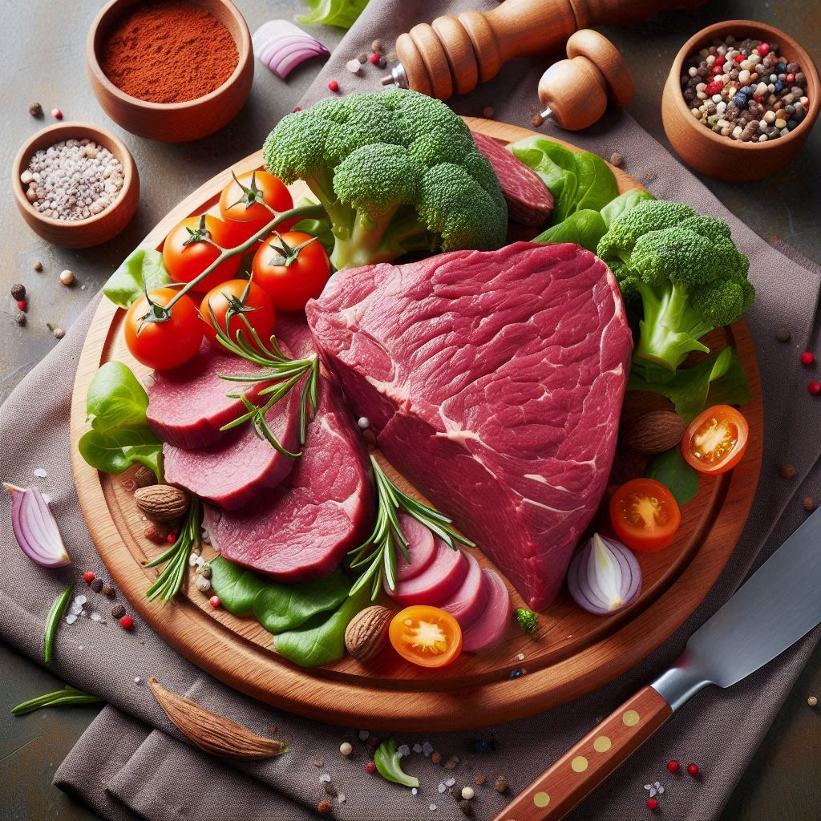 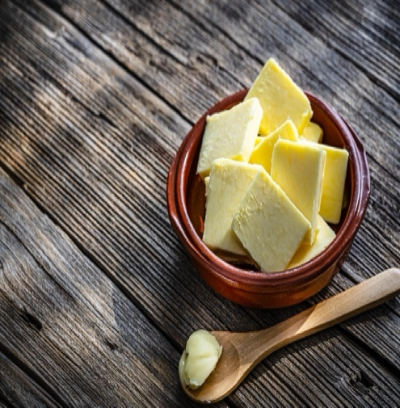

## **REST**

In the winter season, we have more shorter days and colder weather which in a way encourages us to slow down, rest and focus on a spiritual connection with God, self-care, family and friend bonding, lots of laughter. This time of rest is the time to reflect in all areas of life- the spirit, the mind, emotions, etc and a great time to set goals for 2025 and a mental reset.

***“Come to me, all you who are weary and overburdened, and I will give you rest” (Matthew 11:28)***

* Meditation with God and Journaling: Read the Bible and get into His Word,
* Season of Faith: don’t be afraid to try new things, go deeper, realms of creativity, write music, cry, laugh, dream- the Holy Spirit will guide. He wants to open things to you in this 2025- a personal transformation for you. A leap of Faith! Enter in with great anticipation of what GOD is going to do for you!

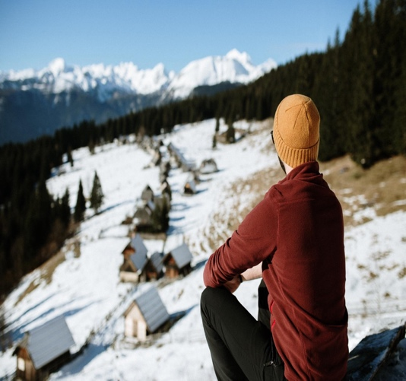

## **PART 5: SAUNAS AND HOT STEAM BATHS**

During this time, the sun doesn’t come out as much. The sun is a huge immune-system booster for our bodies. We need Vitamin D and the best form of Vit D is the sun. we can take supplements, which I recommend, but it’s not the same. You will notice some countries or states that have full sun even during the winter months you see a decrease in illnesses and colds.

We also notice during this time we sleep longer hours, either or body is needing rest for such heavy meals and foods we ate during the holidays or simply the winter blues, which is primarily due to lack of sunlight and can cause symptoms of depression, including fatigue and sleepiness. A hot bath, sauna or steam is great for detoxing your body.

## hot steam bath sauna winter relaxation

## **Exercise / Movement**

During this time, we spend more time indoors, which reduce our movements whether walking or even going to the gym. The winter months helps for your body to rest and recover and during this time it is important to make healthy choices for your body. Normally, we start to hydrate less since we are working out less, but our body craves for magnesium and healthy drinking water.

 

**Consagrar™** **Copyrighted© 2025**